Introduction

Forgan Arts Centre is recruiting four Lead Artists to deliver high quality arts activities for children aged 5-12 years as part of the Summer edition of Children’s Art Club. This role is suitable for someone with a strong interest and experience working with children and art education. This is a fixed term, freelance position of four days.

Contents

About Forgan Arts Centre 1
Key Details 2
Responsibilities & Specification 3
Application Process 4
Further Information 6
Application Form 7

About Forgan Arts Centre

Purpose

Forgan Arts Centre sits on the edge of the village of Newport-on-Tay in North East Fife. It is a community-led arts centre delivering creative activities for the people of Fife, and beyond. Our programme includes art and craft classes, workshops, artist-led projects that respond to community need, artist commissions, residencies, placements, and public events. We provide allotments, artist studios, and professional making facilities. We have on-site accommodation in the Gardener’s Cottage. Through diverse creative practices, we work with artists while listening to our communities to address individual and collective challenges that resonate locally and globally. We are a part of the local ecology providing access to creativity and a site for the exploration and understanding of the natural environment. We provide a warm welcome and take an approach to accessibility that supports individual needs.

An Arts Centre as a Garden

In 2024 we developed a new business plan for the period 2025-28. During this time the centre’s activities and operations will be conceptualised as An Arts Centre as a Garden. This is an experiment: imagining an art centre as a garden where a multisensory and sentient ecology of plants, people, and creatures support one another through mutually beneficial relationships.

An Arts Centre as a Garden is an example of social permaculture, a concept by which communities look to natural environments to model co-existence and co-creation. Responding to local consultation and applying the social permaculture concept, we have identified three themes as the focus of our activity for the three-year period, 2025-28. Through these themes we will engage with local community concerns; wider social issues; our EDI (equalities, diversity and inclusion) and environmental aims; the National Performance Framework; and the UN’s Sustainable Development Goals, drawing inspiration from the intelligence and lifecycles of the natural environment.

Key Details

Role title: Lead Artist
Responsible to: Programme Producer: Learning & Engagement
Responsible for: Children’s Art Club participants.
Status: This is a self-employed/freelance position.
Fee: £1162 flat fee including preparation and any expenses.
Hours: Monday-Thursday, 8.30am-4.30pm.
Duration: Either
- Mon 6 – Thu 9 July
- Mon 13 – Thu 16 July
- Mon 20 – Thu 23 July
- Mon 10 – Thu 14 August
Location: All activity will be in Forgan Arts Centre, Newport-on-Tay, North-East Fife.
Budget: Each Lead Artist will have a materials budget of max.£120.
Benefits: There may be opportunities for continuing professional development and training.

Please note, if you are applying outwith the region or a reasonably commutable distance, we have on-site accommodation in the Gardener’s Cottage which may be available. Please note, the cottage is not fully accessible. We cannot guarantee availability.

About Children’s Art Club

Children’s Art Club is our artist-led creative programme for 5–12-year-olds that runs during school holidays. With a different Lead Artist each week, participants are introduced to different art forms and creative thinking that encourages them to fully express themselves in a joyful space. Art activities often connect to our outdoor spaces as well as inside and think about our themes of art, ecology and sustainability. Activity planned by the lead artist encourages thinking, playfulness and creativity by exploring different art forms and responding to the children’s interests.

Daily Running Order

Each day is broken up as follows:

9-9.30am | Arrivals. During this time children undertake self-led activities such as colouring in and drawing allowing the Lead Artist and Creative Play Worker to set up for the day's activity.
9.30am-10.30am | The Lead Artist and Creative Play Worker introduce and start the session.
10.30-11am | Snack break. Snacks are prepared and provided by the Centre.
11.30am-12.30pm | Art activities continue.
12.30-1pm | Lunch break. Children bring packed lunches.
1-3.30pm | Art activities continue.
3.30pm | Children are picked up.
3.30-4.30pm | The Lead Artist and Creative Play Worker tidy up and a cup of tea.

Please note, these timings are approximate and may change daily depending on the needs of the activity or participants. Depending on the weather and participants, it might be that the afternoon is broken up with outdoor games or activities in the gardens that allows everyone to run around and play.

Responsibilities & Specification

Each Lead Artist will provide four days of high-quality art activities to a group of up to 20 children. Some children will attend for all four days and others one or two days. Therefore, activities should change daily, but should relate to one theme, enquiry or aspect of your practice. The Lead Artist is supported by a Creative Play Worker who is experienced and qualified in working with children.

Duties include:
- Devising an engaging and thorough programme plan with strong artistic activities and thematic links.
- Preparing art activities for the sessions.
- Advising the Creative Play Workers of activity content and how best to set up the workspace and how to support you.
- Welcoming the children to the centre and helping them settle in and feel comfortable.
- Providing children with clear instructions and ongoing support to fully engage in activities both indoors and out.
- Helping to maintain a clear and clean working space when possible.
- Moving tables, chairs, and setting up the space.
- Assisting in the tidying up between/at the end of the sessions.
- Being responsible for the safety and safeguarding of the children with Creative Play Worker.
- Upholding and enacting the centre’s safeguarding policy for the care and safety of the children.

Key experience, interests, and skills:
- Experience in art & socially engaged practice
- A strong interest in art and creativity.
- Knowledge and experience in your chosen art form/activity.
- Strong communication skills.
- Knowledge and experience of leading groups and children in a busy environment.
- Ability to be adaptable depending on the needs of the group or changes in plans/weather and other factors.
- Experience working with children with additional support needs is desirable but not essential.
- PVG desirable but not essential at time of applying. We can support you in this process.

Application Process
To apply please send the following documents via email to programme@forganartscentre.co.uk
- Application form: a blank template is available at bottom of this document.
- Documentation of previous work: ideally 5-10 images or up to 10 minutes of video.
- CV: detailing previous projects and relevant experience.
- Equalities monitoring form: It is not compulsory to complete this form, but it will help us assess the accessibility of our opportunities if you do. A blank template is available to download on our website.

Please submit documents as PDFs only.

Selection Process

Applications will be assessed by a panel of centre staff. Shortlisted applicants will be invited for a brief and informal online conversation where they can tell us more themselves and their proposal.

Advertised: Friday 17 April
Deadline: 12 noon , Monday 11 May
Informal conversations: Monday 18 & Tuesday 19 May
Interviewees informed: Friday 22 May

Interviews will be informal and via phone or Microsoft Teams.

Successful applicants will need to have final activity proposals and materials lists completed by Friday 29 May so we can accurately advertise the activities and artists can source the required materials.

Equal Opportunities

It is our policy that there shall be no discrimination on the grounds of gender, race, ethnic origin, marital status, religious belief, sexual orientation, disability, age, nationality or national origin in any matters to do with employment.

Further Information

Website

You can find out more about Forgan Arts Centre via our website. Key pages would be:
- Who we are will tell you more about the existing staff team.
- Art programme will tell you more about our projects, commissions, residencies, and some of the artists we’ve worked with.
- What’s on will show you some of our classes, workshops, and events
- What we do shares more about our history as well as our annual accounts and current vision, mission and aims. Please note, in 2025 we will launch our new business plan, An Arts Centre as a Garden. This is not published yet.

Social Media

Our website is still in development which means it doesn’t capture everything we do. You can find out more on our social media sites:
- Facebook: facebook.com/forganartscentre
- Instagram: instagram.com/forgan_arts_centre/
There are also three videos documenting some of our projects on Vimeo which you can watch via this link: vimeo.com/user214485190
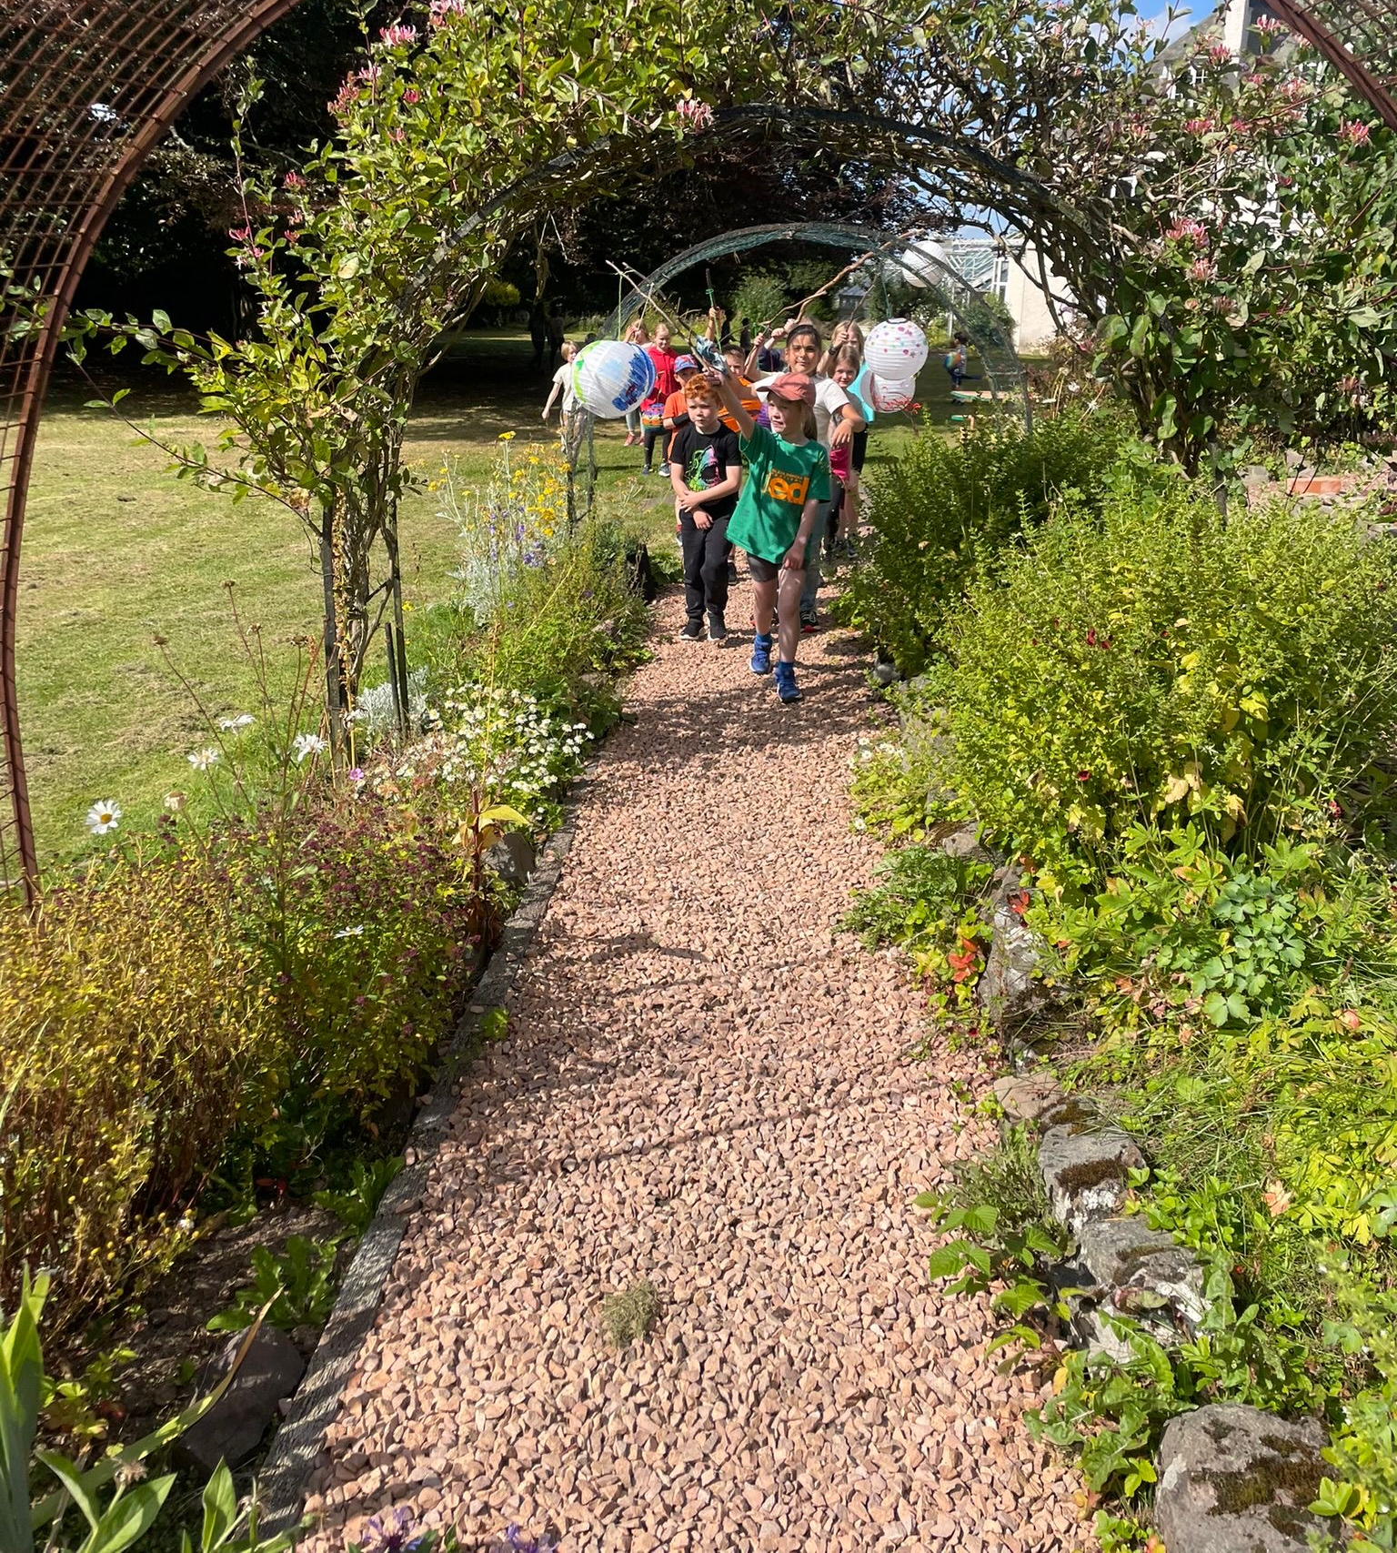
Image of the planet parade around the Centre’s gardens during Children’s Art Club curated by artist Rosies Roberts, 2024.
Image credit: Rosie Roberts

Application Form

Video applications
If you prefer, you are welcome to submit a video application. A video application should include all the elements of the proposal. A written CV, budget, and portfolio would still be required, as a PDF. We recommend a five-minute-long recording using your phone, webcam or platform such as Zoom. Recording in a quiet space will ensure good sound quality. Upload your video to Vimeo or YouTube as ‘unlisted’ but viewable by anyone with the link. Include the link to your video in your application.

Name:
Email address:
Address:
Mobile/phone number:

Tell us about your proposed activity for Children’s Art Club, this can be for 1 day or for full 4 day week. (max. 750 words)
Your answer should include:
- The art form(s), theme, and area of exploration.
- What the children will do.
- How could the activity be tweaked for ages/abilities.
- Is this an indoor or outdoor activity?
Note, activities do not need to be output focused. The focus should be on process – creating a quality developmental experience for the child – and having fun!
In brief, what are the materials, facilities, and space requirements needed for your proposal? (max 150 words)
- This is to help us assess cost, your needs, and to help with planning.
- Please note, the following materials are available at the centre and we encourage their use: paper, collaging materials, cardboard, paint, pencils, felt tips, crayons, scissors, ‘safe-saws’, air-dry clay. In addition, the grounds and gardens are free for you to use.
- Please choose sustainable materials, this is core to Forgan Arts Centre’s principles.
Please provide a link to your website or Instagram for your practice if applicable.
Are you registered with the PVG scheme?
Do you need accommodation?
Which week are you applying for?
Please complete the Equalities Monitoring Form

https://www.surveymonkey.com/r/7N6BXP5

Checklist

Have you read the job description? | Y/N
Have you completed the application form? | Y/N
Have you an up to date CV? | Y/N
Have you completed an Equalities Monitoring Form? Note, this is voluntary and will not impact the assessment of your application. | Y/N

Please email your completed application form and CV to programme@forganartscentre.co.uk

GDPR and Data Protection Act 2018

Forgan Arts Centre will only use the information submitted in this application form for the purposes of this recruitment process.

