About Us

Forgan Arts Centre is a home for artistic production, experimentation, and learning in North East Fife.

Originally established by members of the local community in 1974, for five decades we have been delivering creative learning in art and craft. In 2022, we moved premises to The Leng Home estate. Since then, we have presented a new programme of socially engaged projects, artist commissions, residencies, community activities and events with an expanding network of artists and partners, alongside our art and craft classes.

We are specialists in ceramics, glass, painting, and upholstery, as well as the foundational practice of observational drawing. Our new context means we are custodians of almost three acres of land and gardens. Drawing on the deep connections we have with our local community and our commitment to protecting the natural environment, we are cultivating a site that has people and the planet at its heart.

Facilities include a pottery, multi-purpose classrooms, and tools for stained glass, printing, and textiles. We have outdoor space with mature woodland, food growing plot, allotments, and lawns.

The role of tutor is a paid, self-employed position. Tutors are paid for weekly, recurring classes at a rate of £26.50 per hour. Tutors are paid £32 per hour for one off workshops. Tutors are offered training and development opportunities. Tutors are key contributors to the development of the centre’s strategy and future plans.

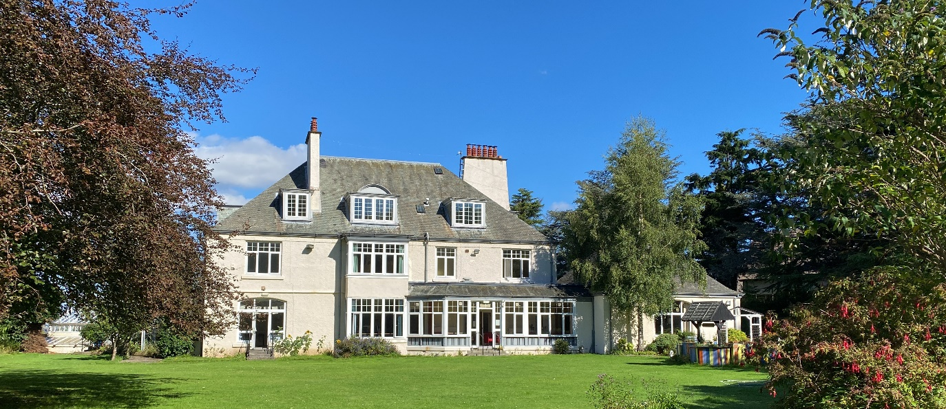

About You

We want to hear from artists, makers, and craftspeople, who want to teach their skill. We're open to activities that aren't already in our programme, as well as those that are. We may not have the specialised facilities or tools required for your activity. But we’re open to investing in these.

We are committed to providing high quality arts education and believe teaching is a practised skill. Therefore, we expect that you will have experience teaching or tutoring. This may be through workshops, community activity, or within a school environment. We also expect a demonstrable level of skill and experience in the activity you wish to teach. This may be self-taught, or through formal study.

The following page is a template for submitting an expression of interest (EOI) in working with us. If you’re not sure what information to include, don’t worry. We will respond to all EOIs to ensure we have the information we need.

It is not compulsory to complete an Equalities Monitoring Form, but it would help us assess the accessibility of our opportunities.

Expression of Interest: Tutors

Name:
Address:
Email:
Phone number:

Tell us about your practice and what activity, craft, or art form you’d teach:
Please let us know:
- What the art, craft, or activity is
- What materials and equipment you use
- What else you need to deliver a course, class, workshop, or masterclass
- The number of students who you could comfortably support
- Who would this class be for? (Beginners, improvers, or experienced people)
Have you experience teaching?
Whether this is formally or informally, tell us if you feel confident teaching people.
What days and times would you be available to teach?
We’re open Mon-Sat, 9am-9.30pm. Please note, we’re especially interested in evening and weekend activity. We can support weekly and monthly classes and one-off activities.
Is there anything else you’d like to share?
Including access requirements, periods of unavailability, or other support you’d require to deliver your activity.

Please include example(s) of your work in a format that suits you or a link to your website or social media if appropriate.

This is a rolling deadline, and we welcome expressions of interest throughout the year.

Please email your expression of interest to our Centre Coordinator, Alana Peden, alana@forganartscentre.co.uk.

